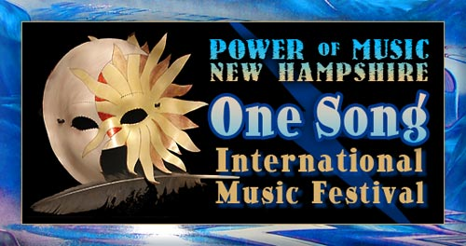
With Innovations for Humanity Summit, Exposition & Conference
powerofmusicnh.com
Event Director: B.Hughes 928-202-1447

Email form to: b@powerofmusicnh.com

Speaker and Workshop Fact Sheet
Please include Bios
Name(s):
Business Name/Product:
Phone:
Email:
Website:
Address:
Brief Description of what you’ll be presenting:

